Studio 2 – Minor Project Pitch

- Devika Menon
S3903569

Rationale

For my minor project I intend to explore how people let themselves be controlled by society, the government, technology, consumerism, etc. and delude themselves that they are free, because it is easier and more convenient than the alternative – which is to admit how unhappy they really are. I want to explore the themes of dystopian societies as well as mental health. I plan to do this by creating a short 2D animation.

By practice I am an illustrator, and I only made my first 2D animation last semester. As an amateur in the field, my goals alongside exploring these themes include improving my technical skills in animation with a focus on fluidity in motion. I am a bit worried about time constraints and delays that may be caused because of how much I have to learn/teach myself, but I believe it can be achieved if I keep my animation style simple.

I wanted to create something that highlights how in many ways, we are already living in the dystopian society that people used to write fiction about many years ago. I want to explore themes such as loss of individualism, technological and government control, and societal expectations. I am not sure if I will be able to fully explore all these themes in detail in a short animation, but I do intend to highlight these aspects in my script.

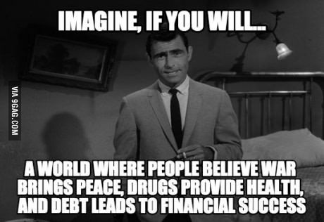

Methods

I plan to create a 2D animation in a fairly simple style, with more focus on colors, shapes, and fluidity of motion.

I have written a short script for an animation that I plan to develop further with practice and consultations.

I always start with hand sketches and then use them as a reference to draw digitally. I am going to be primarily working with Adobe Animate and After Effects. I am fairly new to both softwares, but I believe they are the best option for where I am at right now in terms of technical abilities.

Outcome

The end result I am hoping for is a short 2D animation that is about a minute and a half or so, that explores how we have willingly become a part of “the system” in order to not pay attention to how unhappy we really are. This creates a dependency on external things, such as societal validation, the government, consumerism, etc.

Some questions that have led me to this topic include: Is freedom necessary for a perfect society? Can the government save mankind from itself by eradicating individual will? Do people need to be controlled to manage a functional society?
I want to subtly explore these questions while focusing on how all these dilemmas create a deep unhappiness within the individual.

Context

Some works that inspire me

In terms of Theme:

The Autodale series by David James Armsby – He has created a series of animated shorts based on the fictional dystopian city of Autodale. Each animation explores a different concept about the society we live in, and it is all very Black Mirror.
One of my favorites is “Model Citizen”, which explores a “Perfect” family in Autodale.

https://www.youtube.com/watch?v=mVLrBJYGxk4

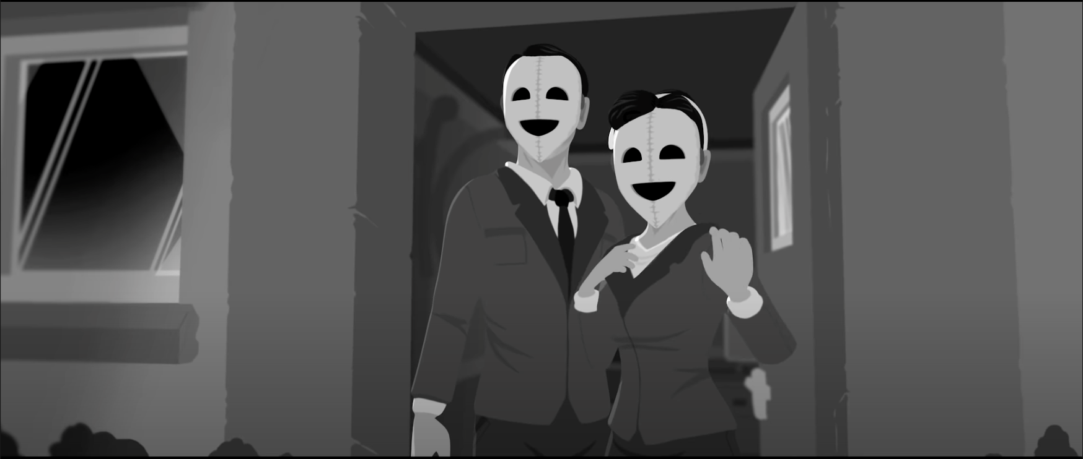

In terms of Style:

Dreaming by Wang Wei-Shen – A visually appealing animation that explores dreams and the dreaming state. He shows how we let our imagination control ourselves in our dreams through colors, shapes, and fluid transitions. The sound and voiceover also add to the overall effect of the film.

https://vimeo.com/231092276

